**Assignment on Simple Linear Regression**

Question 1 ) Calories consumed-> predict weight gained using calories consumed

**Ans : R code**

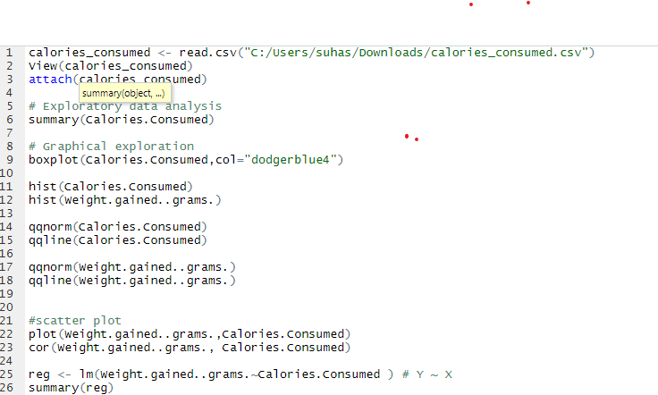

**-----Scatter Plot**

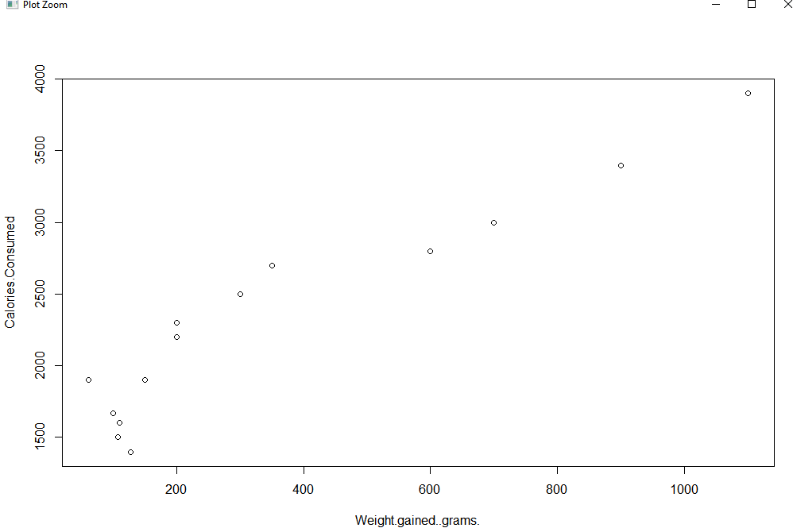

**Output 1 :**

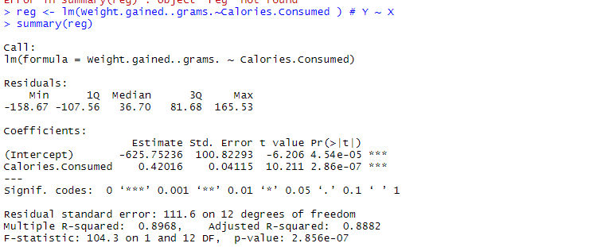

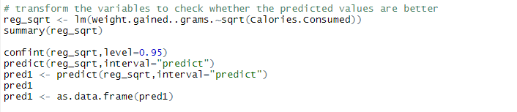

**Output 2 with Squared inputs**

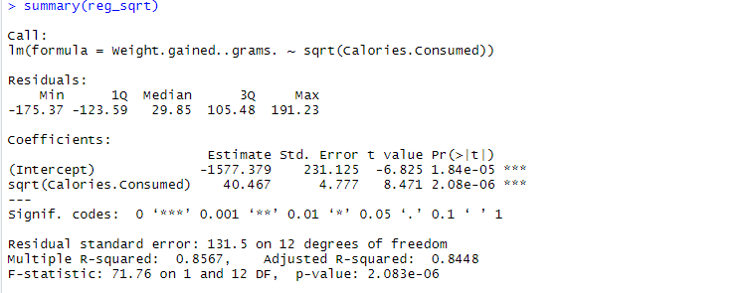

Question 2) Delivery time -> Predict delivery time using sorting time

**Ans :Rcode:**

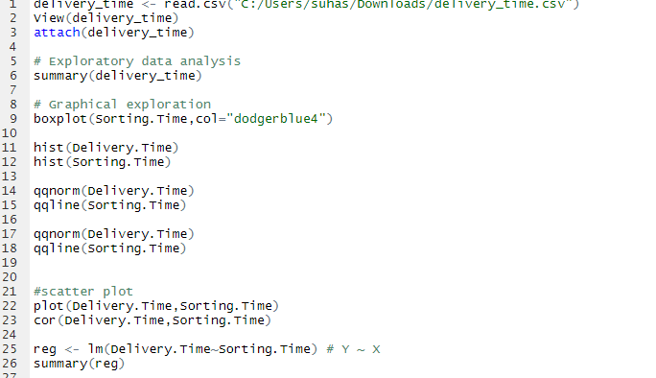

**Scatter Plot**

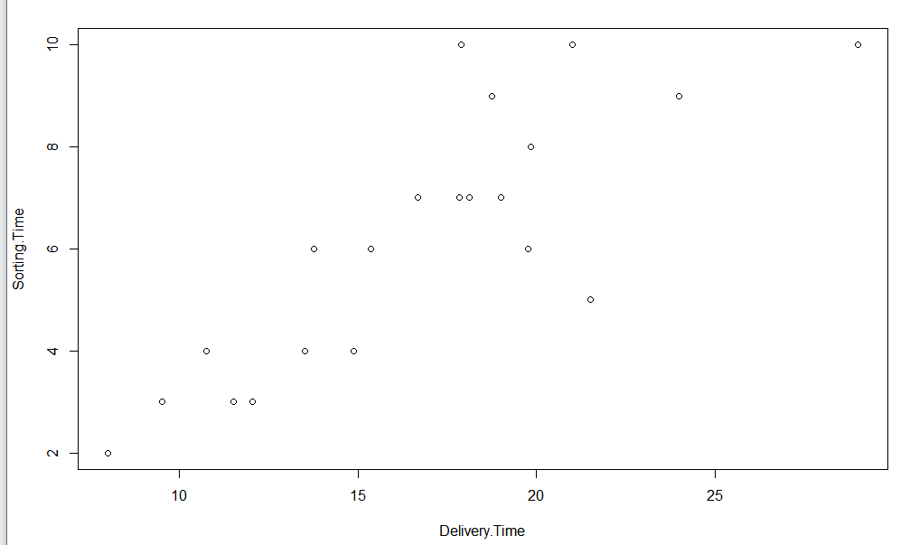

**Output 1 :**

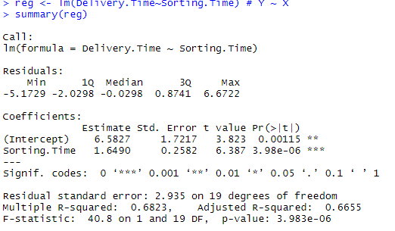

**Transforming Inputs**

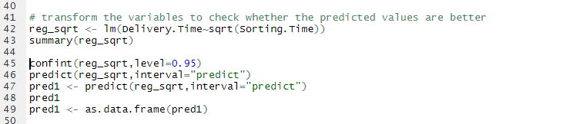

**Output 2 with Squared inputs**

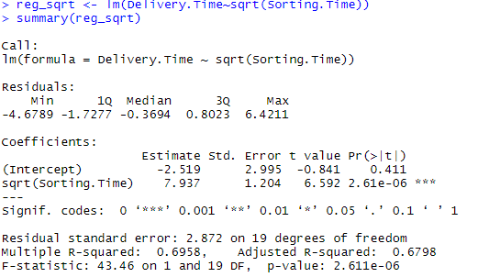

**Output 3 taking log of input**

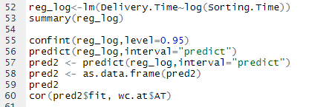

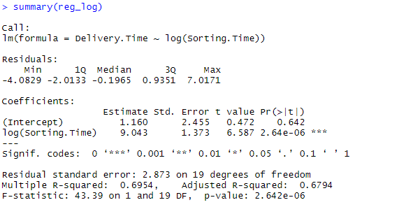

Question 3) Emp_data -> Build a prediction model for Churn_out_rate

**Ans : R code**

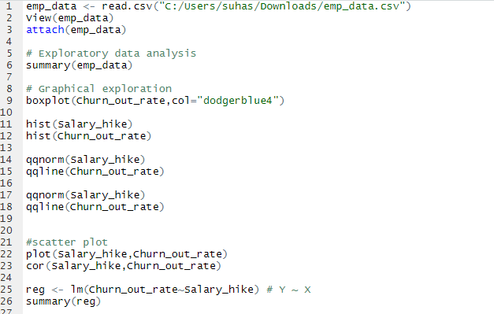

**Scatter Plot**

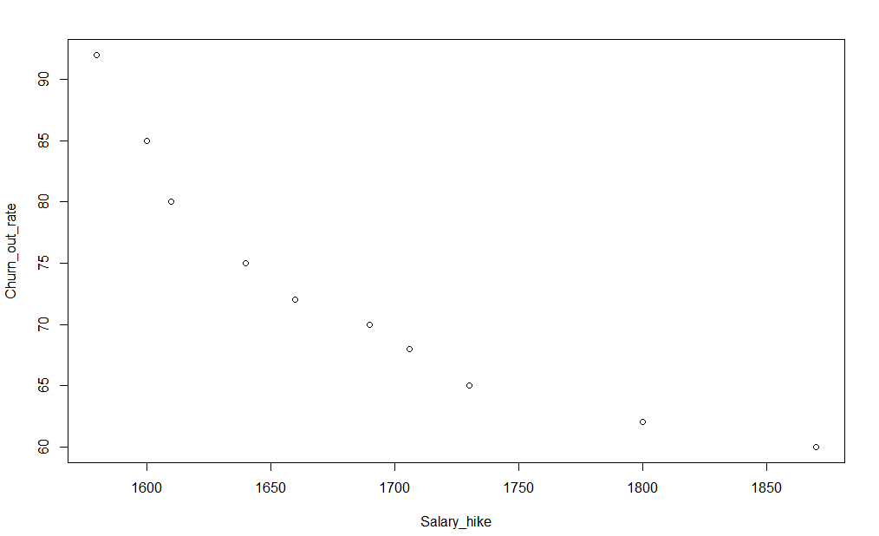

**Output 1 :**

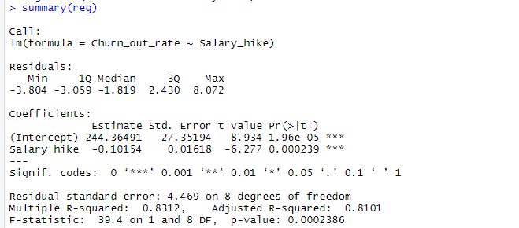

**Transforming Inputs**

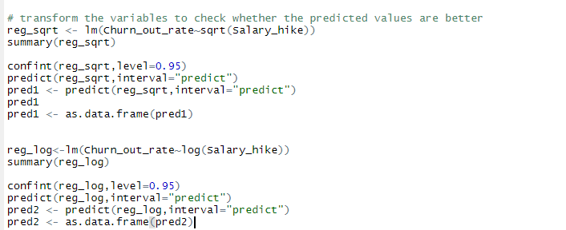

**Output 2 with Squared inputs**

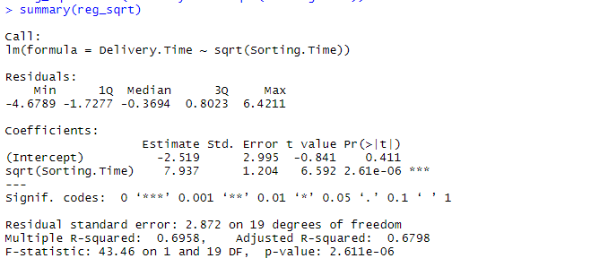

**Output 3 taking log of input**

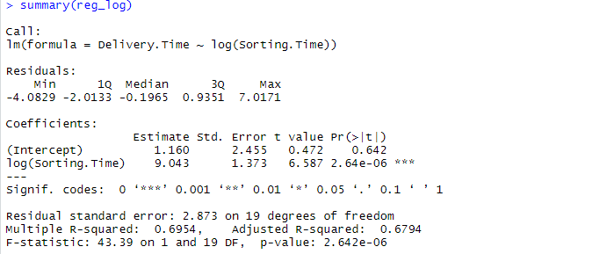

Question 4) Salary_hike -> Build a prediction model for Salary_hike

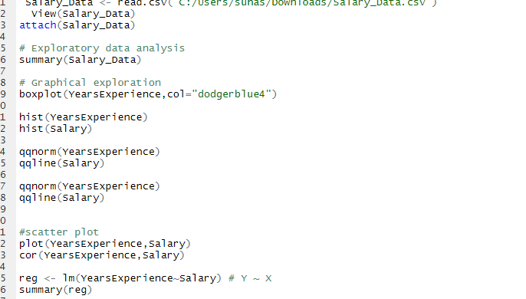

**Scatter plot:**

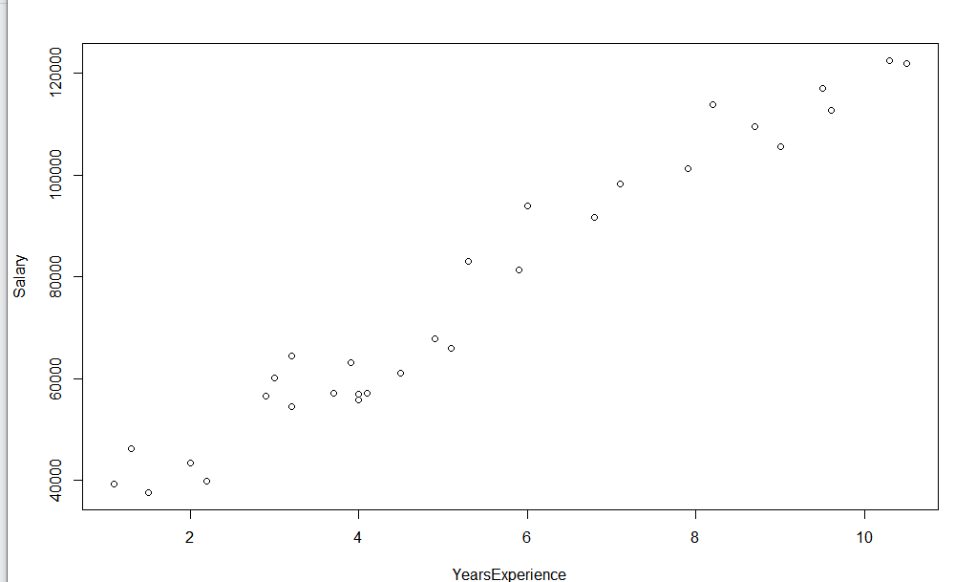

**Output:** 